# [MU123] - TMA01 2025J

## Question 1

**With reference to good mathematical communication (GMC), give 5 reasons why the second solution is better than the first.**

1. **Clear Structure and Layout:**

The student rewrites the question within their solution and uses linking words such as *“so”* to show logical progression. Each step is presented on a new line, which makes the method clear and easy to follow.

1. **Correct Use of Units:**

Units are included throughout the working and in the final answer. This ensures clarity and demonstrates an understanding of how the values change throughout the calculation.

1. **Accurate and Appropriate Notation:**

The student uses correct mathematical notation, including the degree symbol where appropriate. They show sufficient decimal places during the calculation before rounding to one decimal place, demonstrating accuracy and transparency in their working.

1. **Proper Use of the Equals Sign:**

The “equals” sign is used correctly — only once per line and only when it is mathematically appropriate. This avoids misleading statements and maintains mathematical accuracy.

1. **Clear and Concise Conclusion:**

The final answer is written clearly and concisely, with the correct units and notation. The conclusion follows the conventions of good mathematical communication and confirms the reasoning and result.

## Question 2a

**Alex is following a recipe to make a pavlova that uses 280 grams of sugar and 6 eggs. However, they drop one egg and so only have the 5 remaining eggs to use. Calculate the quantity of sugar that Alex should now use to make their pavlova. Give your answer in grams, correct to 2 significant figures.**

The recipe uses 280 grams of sugar for 6 eggs.

Therefore,

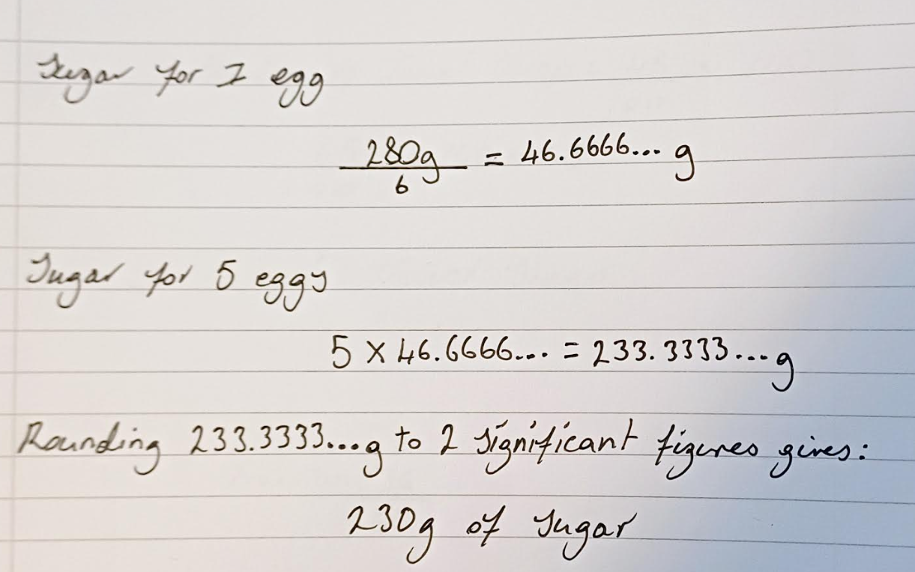

## Question 2b

**The book Is maths real? by Eugenia Cheng has 336 pages. An online preview of the book includes 39 pages. Calculate the percentage of pages that are included in the online preview. Give your answer correct to the nearest whole number.**

The book has 336 pages, and the online preview has 39 pages. To find the percentage of pages included in the online preview:

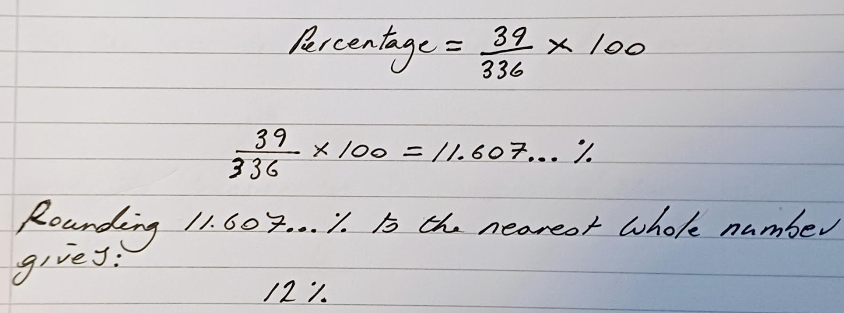

## Question 2c

**A farm has 140 sheep.**

1. **45% of these sheep are Texel sheep. Calculate the number of Texel sheep on the farm. To find the number of Texel sheep:**

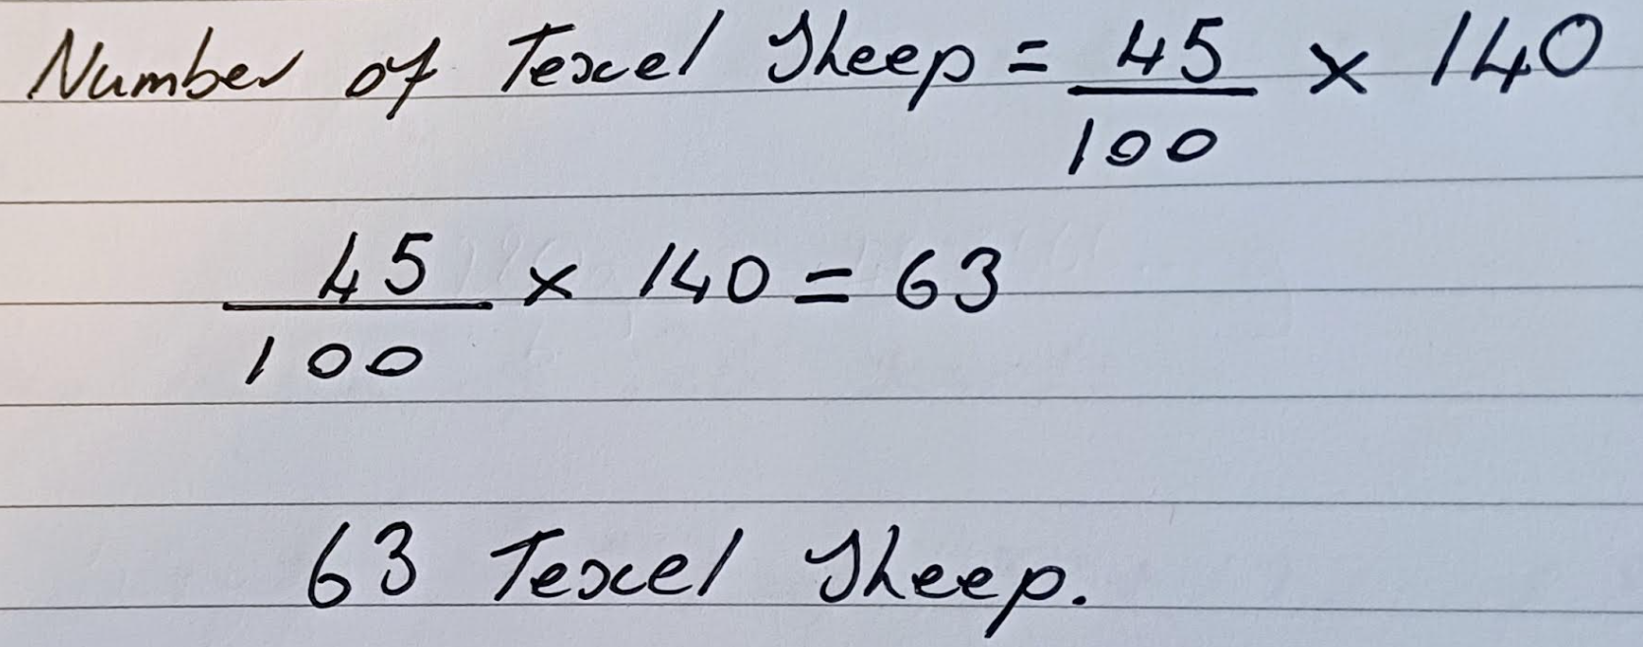

1. **Of these Texel sheep, 36 are lambs (are under 1 year old). Write the number of Texel lambs as a fraction of the total number of Texel sheep on the farm. Give your answer both as an un-simplified fraction, and as a fraction in its simplest form.**

There are 63 Texel sheep on the farm, 36 of which are lambs.

To write the number of Texel lambs as a fraction of the total number of Texel sheep:

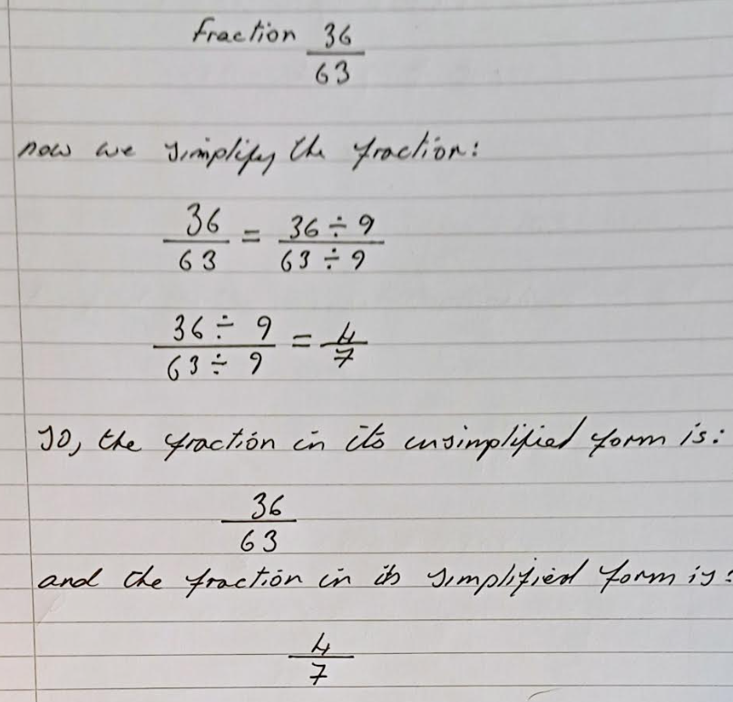

## Question 2d

**Bo, Cal and Drew are each crocheting a scarf.**

1. **At one point, Bo’s scarf is 87 cm long and Cal’s scarf is 19% longer than Bo’s. Calculate the length of Cal’s scarf. Give your answer in centimetres correct to the nearest centimetre.**

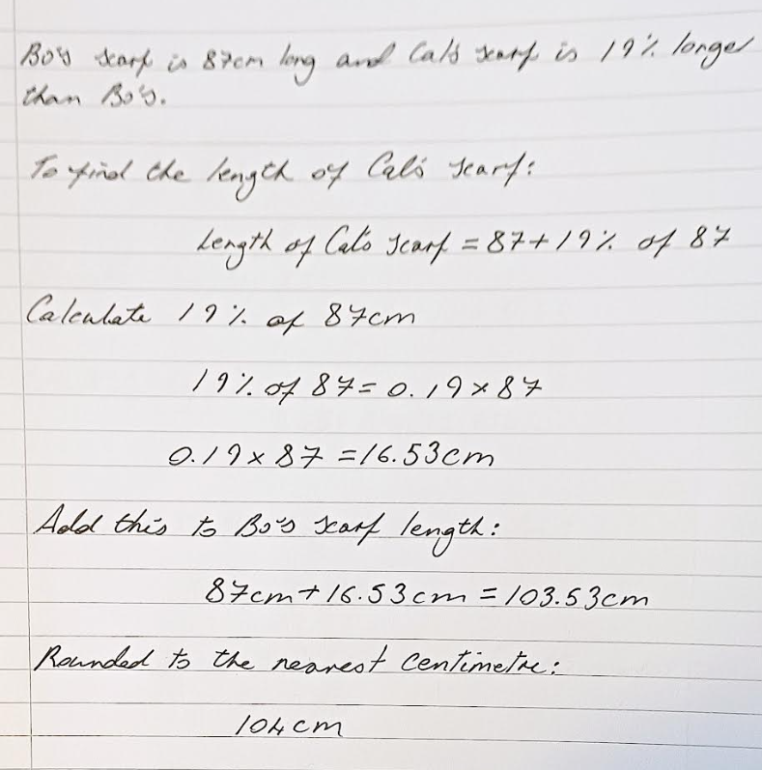

1. **At this point, Drew’s scarf is $\frac{8}{11}$**  **of the length of Cal’s scarf. Calculate the length of Drew’s scarf. Give your answer in centimetres, correct to the nearest centimetre.**

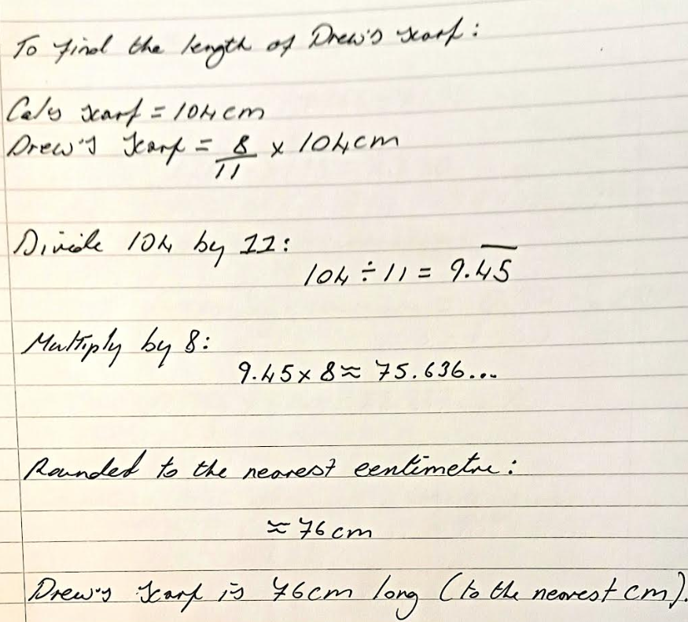

## Question 2e

**The price of a first class Royal Mail stamp increased in October 2024 from £1.35 to £1.65.**

1. **Calculate the percentage increase in the price of a first class stamp. Give your answer correct to one decimal place.**

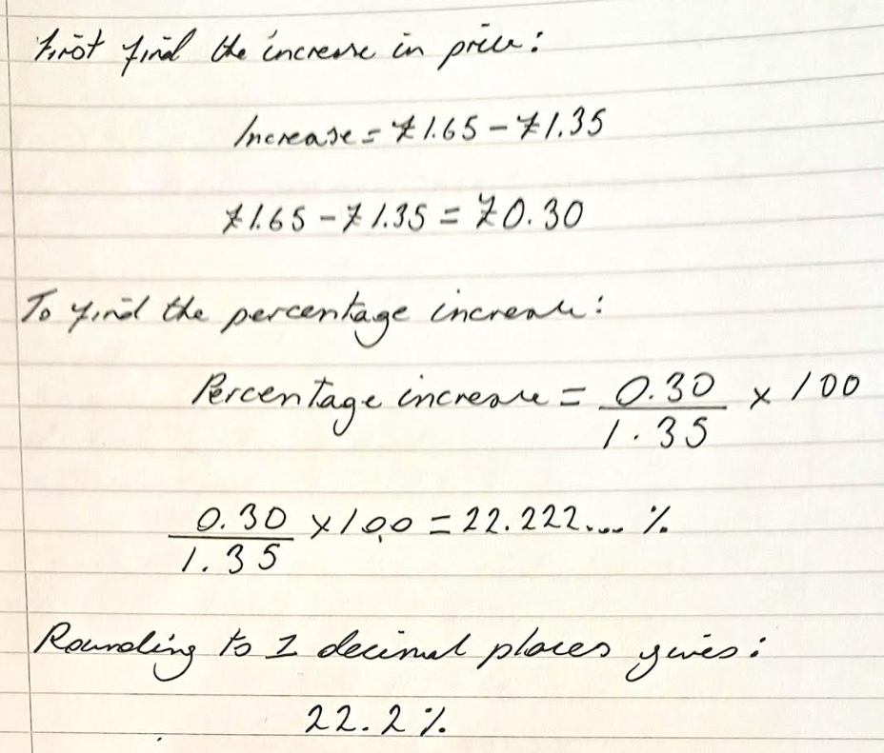

1. **Explain briefly why you used the method you used to answer Question 2 part (e)(i), and why you laid your solution out as you did.**

I used the percentage increase method because the question required the change in price to be expressed as a percentage of the original value. This method clearly shows how much the price has risen in proportion to the starting price, which is the most appropriate approach for this type of comparison. I presented my solution in a clear, step-by-step structure to demonstrate each stage of the calculation and the reasoning behind it. I included the correct notation, units, and rounding at the end to ensure accuracy and clarity. This layout follows the principles of Good Mathematical Communication (GMC) and makes the solution easy for the reader to understand and check.

## Question 3a

**Erin is an endurance (horse) rider.**

**Erin completes a training ride of 28.5 kilometres in 2 hours and 45 minutes. Calculate their average speed for this ride, giving your answer in kilometres per hour (km/h) correct to one decimal place.**

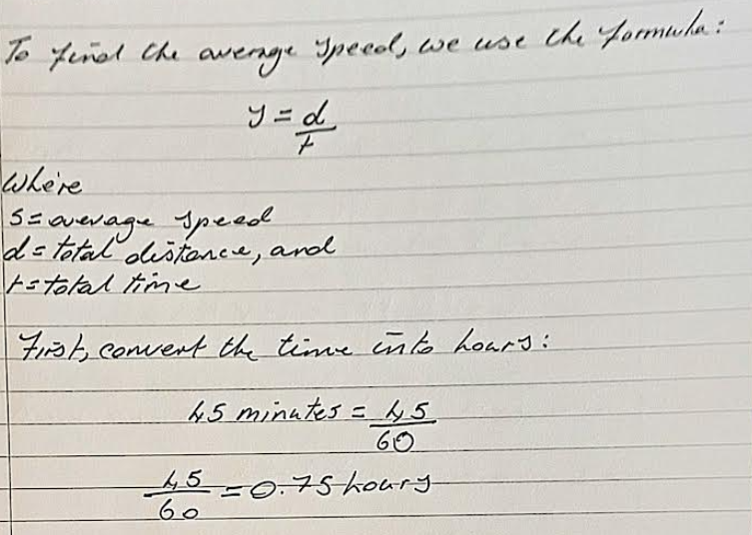

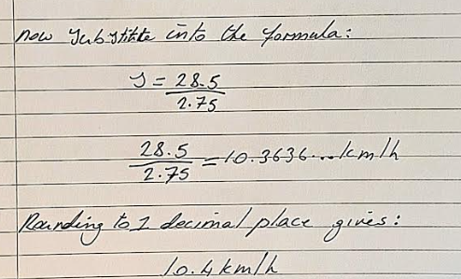

## Question 3b

**The first bridlepath (horse riding trail) on Erin’s training ride measures 34.6 cm on a map which has a scale of 1 : 16 000. Calculate the corresponding distance covered on the ground. Give your answer in kilometres, correct to two significant figures.**

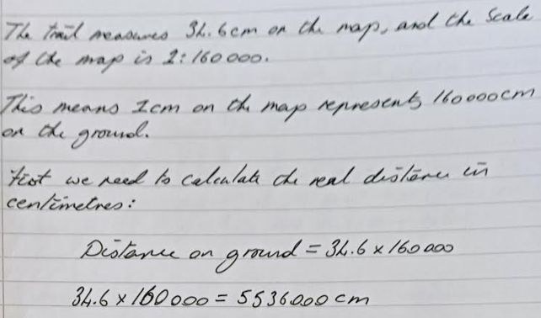

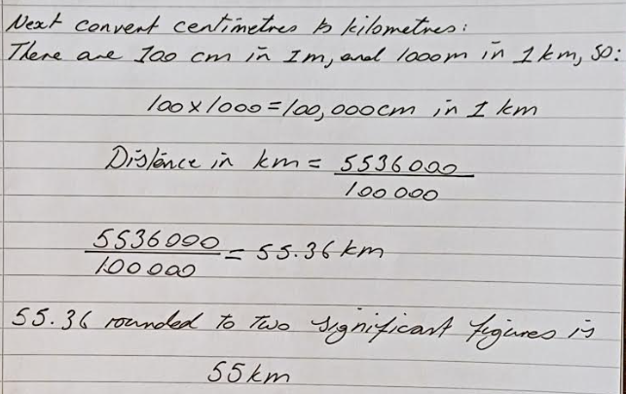

**Erin competes in the young rider category; young riders are aged 14 years old to 25 years old, inclusively. Let y represent the age of a competitor, in years.**

1. **Explain what the inequality y ≥14 means in this practical context.**

The inequality 14 ≤ x ≤ 25 means that a competitor must be 14 years or older to 25 years old, to take part in the young rider category.

1. **Draw a number line to illustrate the range of ages for a young rider.**

Here is a number line showing the age range for young riders — from 14 to 25 years old. You can see the range clearly highlighted.

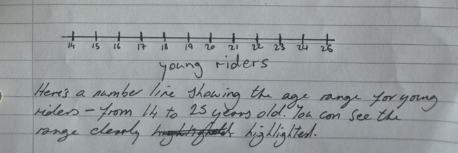

1. **Write down a double inequality, using y, to describe this range of ages.**

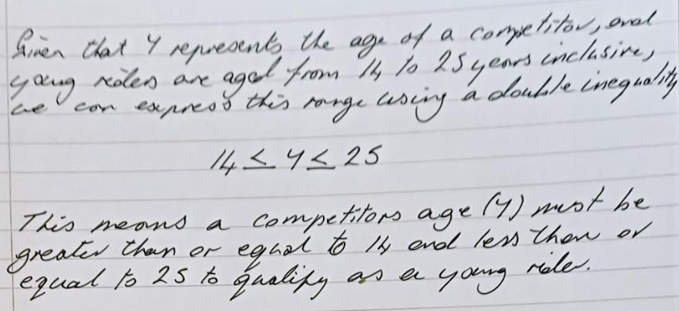

## Question 3d

**Erin enters a competition, a novice Graded Endurance Ride of 35 kilometres. The ride must be completed at an average speed of between 8 and 15 km/h. Calculate the maximum time that Erin can take to complete the ride without being eliminated. Give your answer in hours and minutes, correct to the nearest 5 minutes.**

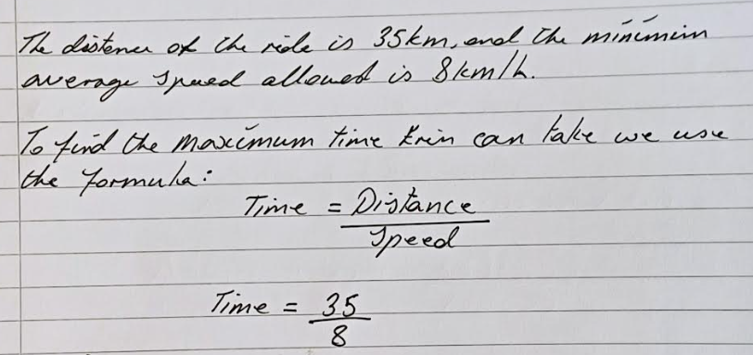

## 

## 

## Question 4a

**After a storm, the water level in the river Derwent near Fu’s home is rising steadily. At 9:00 pm the water is 25 cm above the normal level. The water then rises at a rate of 15 cm each hour, for the next 12 hours.**

**Using this information, complete a copy of the table below.**

**To find the height after t hour use the formula:**

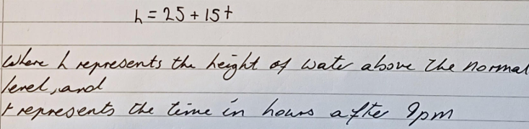

|  |  |  |  |  |  |  |  |
| --- | --- | --- | --- | --- | --- | --- | --- |
| **Time, T, in hours after 9pm** | **0** | **1** | **3** | **4** | **6** | **9** | **12** |
| **Height of water, H, in**  **centimetres above the**  **normal level** | **25** | **40** | **70** | 85 | 115 | 160 | 205 |

## Question 4b

**Mark the points from part (a) on a graph, with the vertical axis showing H, the height of water above the normal level in centimetres, and the horizontal axis showing T, the time in hours after 9pm. Draw a line through these points.**

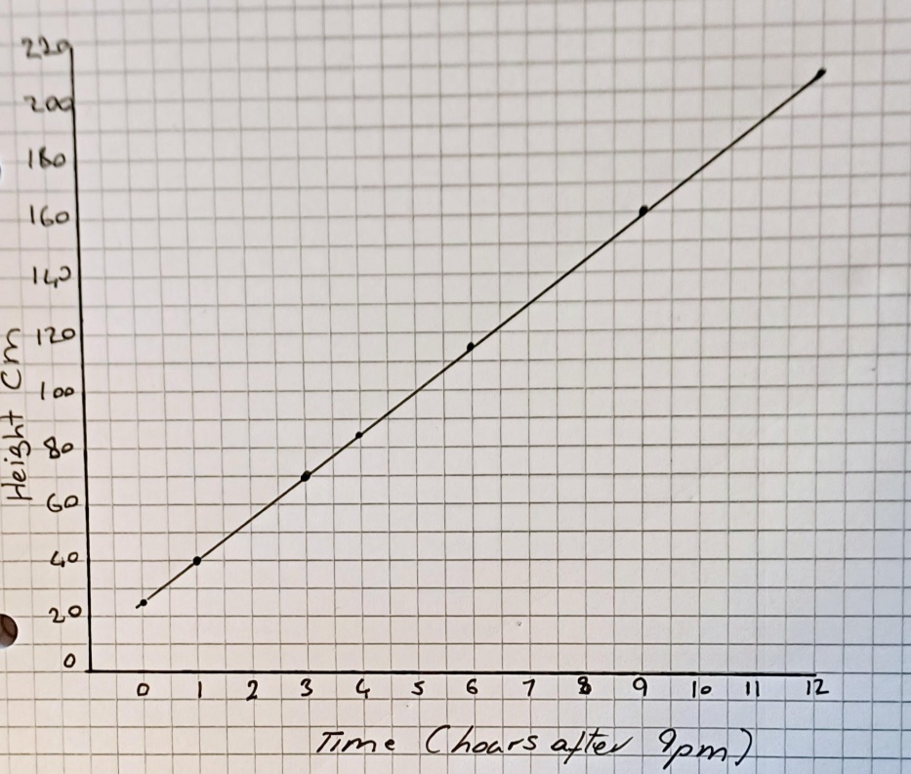

## Question 4C

**Fu’s garden floods when the water level exceeds 190cm above the normal level. Explain how you could use your graph to find the time in hours after 9pm when Fu’s garden starts to flood. What time is this?**

Flooding starts when the water level exceeds 190 cm above normal.

Using the graph:

1. On the vertical axis (height), locate 190 cm.
2. Draw a horizontal line across to meet your straight graph line.
3. From the point of intersection, draw a vertical line down to the time axis.
4. Read off the time t (hours after 9 pm).

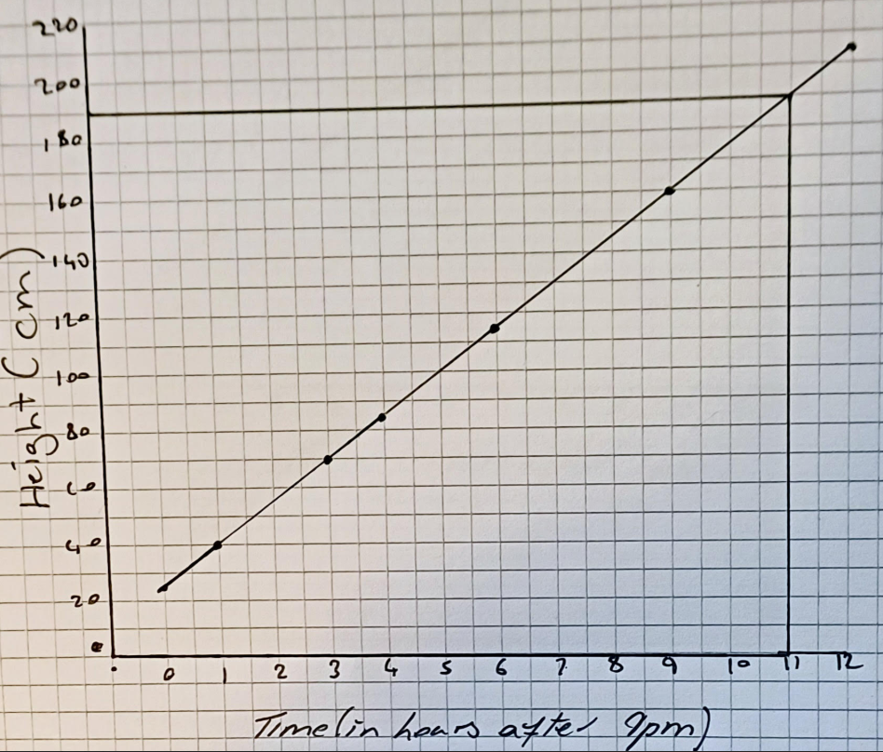

From the graph this occurs at about *t* =11

t = 11 hours.

Therefore,

9pm + 11h = 8am

Fu’s Garden begins to flood at 8am.

## Question 4D

**Fu’s home is at risk of flooding when the water level exceeds 240cm above the normal level. They decide to go to sleep as normal and not move any of their belongings upstairs. In your opinion, was Fu’s decision to go to sleep as normal sensible? Explain your answer with reference to your answers to parts (a) to (c)**

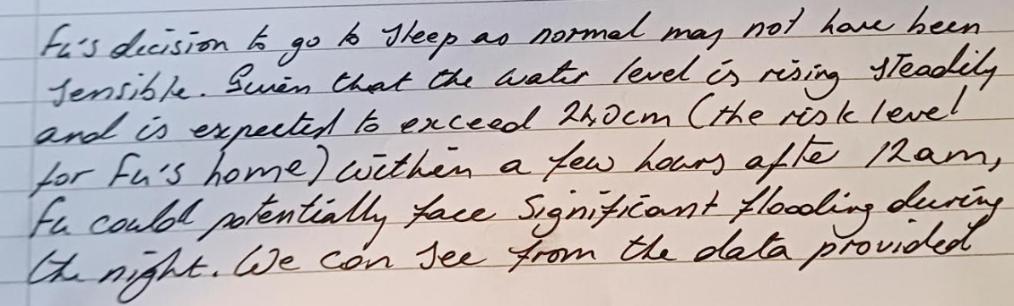

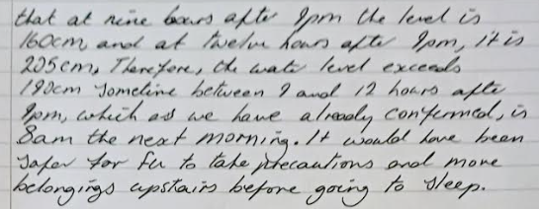

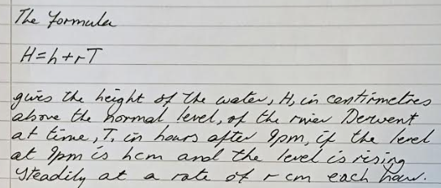

**(e) Explain how you would use this formula to calculate the height of the water if the level is falling steadily by 20cm each hour.**

Using the formula H = h + rT

Where H represent height above normal (cm) after T hour, and

H represents height after 9pm (cm),

R represents rate of change (cm) per hour, and

T represent time in hours after 9pm.

If the level is falling 20cm each hour, the rate is negative:

r = - 20 T

Substitute r = - 20 into the formula:

H = h – 20 T

## Question 4f

**Use the formula to find the height of the water, H, in centimetres above the normal level, of the river Derwent at 4am when the level at 9pm was 140cm and the level is falling steadily at a rate of r = −4.3cm each hour. Show each step of your working clearly. Give your answer correct to three significant figures**

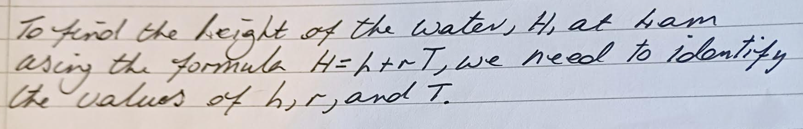

Given that:

Formula H = h = r T

Where h = 140 cm (height at 9pm)

R = -4.4cm/h (falling)

From 9pm to 4am is T = 7 hours.

Substitute:

H = 140 + ( -4.3) x 7

Calculate:

( -4.3) x 7 = -30.1

H = 140 - 30.1

140 – 30.1 = 109.9 cm

Rounded to three significant figures:

110cm

## Question 5

1. **(i) Read over Subsection 5.3 of Unit 1 (pages60–64,BookA). Write down two points about good mathematical communication that you have tried to put into practice in writing your answers in this TMA.**

1. Clarity and logical structure

I have aimed to present each solution in a clear and logical sequence, ensuring that every step follows naturally from the previous one. This approach allows the reader to follow my reasoning easily and understand how each conclusion has been reached.

2. Accuracy in notation and presentation

I have used correct mathematical symbols, terminology, and units consistently throughout my work. By maintaining accurate notation and clear presentation, I have sought to communicate my methods and results precisely and professionally.

**(ii) For each point that you mentioned in part (a) (i), give a specific example(e.g. Question 3 (b) from this TMA where you have put the point into practice. Give a separate example for each point from part (i).**

**1. Clarity and logical structure**

I demonstrated clarity and a logical sequence in **Question 3(d)**, where I calculated the maximum time Erin could take to complete the endurance ride. I began by identifying the relevant information, then stated the formula, showed the substitution, carried out the conversion from hours to minutes, and finally presented the rounded answer. Each step followed on from the previous one in a clear order, which made my reasoning easy to follow and showed how the conclusion was reached.

**2. Accuracy in notation and presentation**

I showed accuracy in notation and presentation in **Question 4(c)** when I used the formula $H=h+rT$ to calculate the height of the water above the normal level. I used the correct algebraic notation, clearly labelled the variables, and included units consistently (cm and hours). I completed the calculation logically and gave the final answer to the required degree of accuracy. This ensured that the method and result were communicated precisely and professionally.

1. **Your tutor will award up to eight marks for good mathematical communication in Questions 2, 3 and 4 of this TMA , and will comment on your mathematical communication below.**

## Question 6

**You are encouraged to use the form on the next page for your answers to this question. Alternatively, you can construct your own similar form**

1. **Write down the cut-off date for MU123 TMA 02**
2. December 2025
3. **Describe one factor that will affect how you plan your work on MU123 between now and the cut-off date for TMA 02. How do you intend to take this factor into account? For example, this could include other commitments, such as family or work, or factors resulting from your work on TMA 01 or iCMA 41.**

One factor that will affect how I plan my work on MU123 before the cut-off date for TMA 02 is what I learned from completing TMA 01 and iCMA 41. I realised that I needed more time than I expected to work through some of the mathematical concepts and to check my answers carefully before submitting.

To take this into account, I intend to start TMA 02 earlier and spread the work out over several shorter study sessions. I will aim to complete the first draft at least a week before the deadline so that I have time to review my answers, reflect on feedback from TMA 01, and improve any areas where I struggled. This should help me manage my time better and reduce stress near the deadline.

1. **TMA 02 covers work from Unit 3 (Numbers), Unit 4 (Statistical summaries) and Unit 5 (Algebra). Look quickly through these units so that you get an idea of what to expect.**

**Which of the following statements apply to you? You can choose one or more.**

**A: I am fairly confident that I can complete the TMA on time.**

**B: I am concerned that I may not have enough time to complete the TMA on time.**

**C: I am concerned that I may not be able to cope with some of the maths in Units 3, 4 and 5.**

**D: None of the three statements A, B and C, above applies to me.**

1. I am fairly confident that I can complete the TMA on time.
2. **Write a brief explanation of your choice of options in part (c).**

I selected option A because I feel more confident after completing TMA 01 and working my way through this module. I now have a better understanding of how to plan my study time and how much work is required for a TMA. I believe that, with regular study sessions, I will be able to stay on track and complete TMA 02 by the deadline.

1. **Describe the benefits you hope studying MU123 will bring, in your studies, personally, or in your workplace.**

Studying MU123 will help me build stronger mathematical skills and improve my confidence when working with numbers. I hope this will benefit my future studies by giving me a solid foundation to progress to higher-level modules. Personally, I expect the problem-solving and logical thinking skills I develop to help me in everyday situations, such as budgeting and decision-making. In the workplace, being more confident with maths will support me in analysing information more effectively and communicating it clearly to others.